**Hands on:**

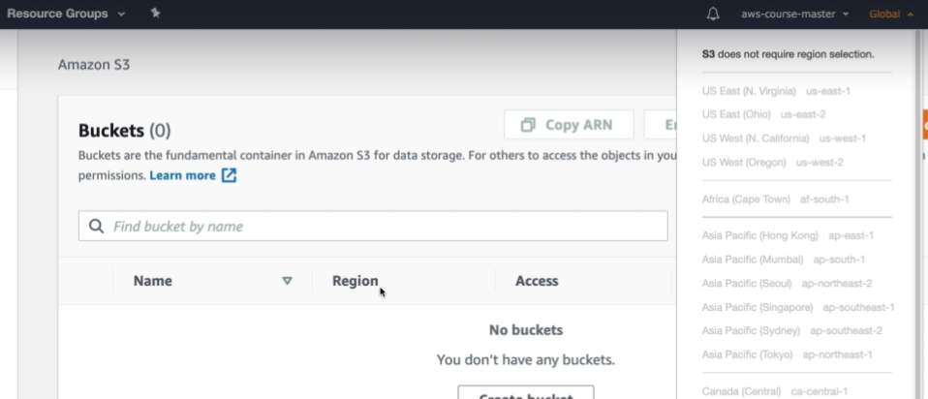

* When we see as above, there won’t be any regions to select when we open s3 service. Because it is not a region specific
* But the buckets are region specific.

**Creating bucket:**

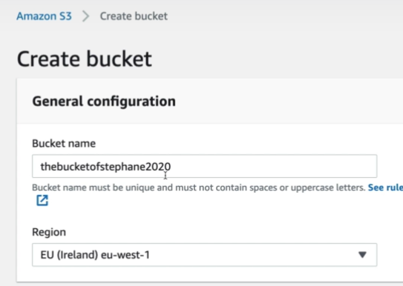

* We need to select the region while creating a bucket as above.

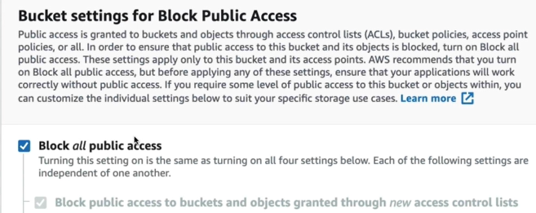

* We can select the above option so that bucket won’t be public.

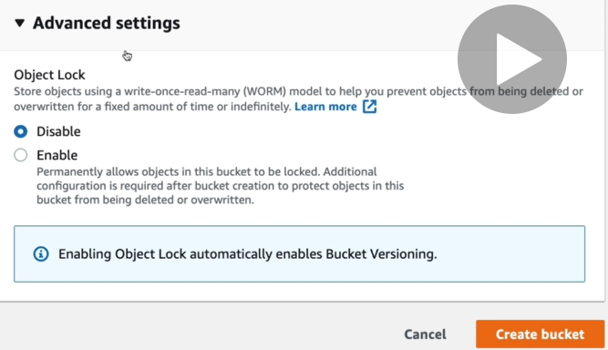

* We can enable the object locks in advanced settings while creating the bucket as above.
* By default, it gets created under standard class

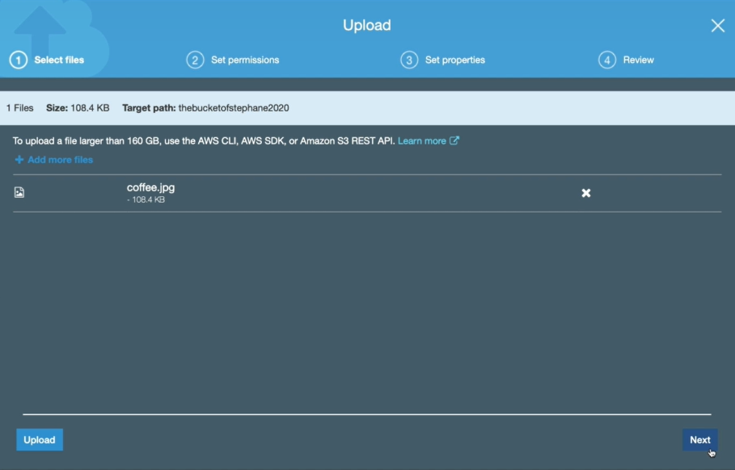

* While uploading the file inside a bucket, we can simple select a file and click on upload button or we can click on net button for more options as above.

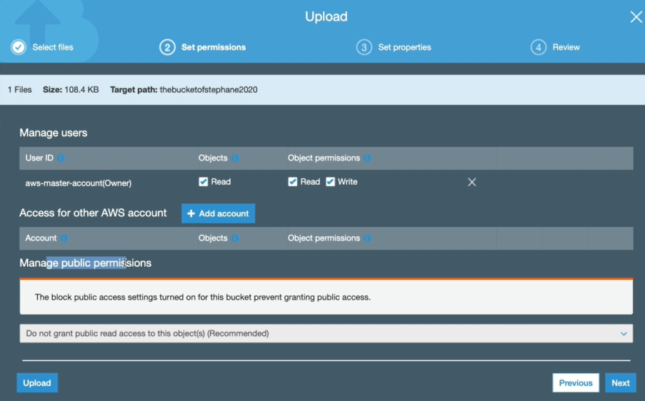

* We can set the permissions as above for read and write access on the file. We can add other AWS accounts also.
* Right now, we can’t manage public permission because we disable it at the time of bucket creation.

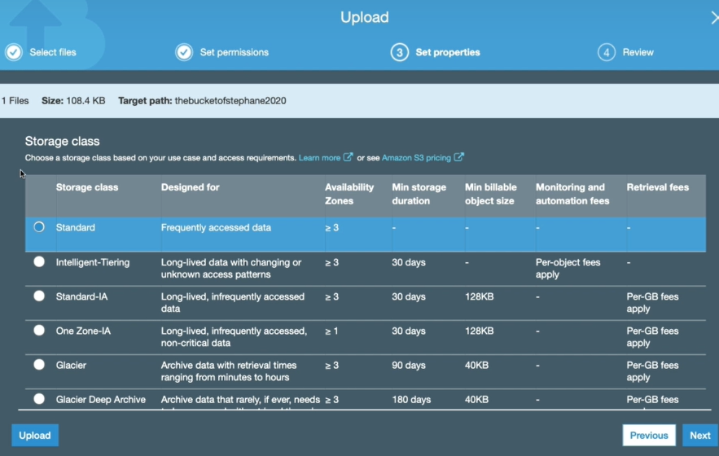

* In net option, we can select the storage classed types as above.

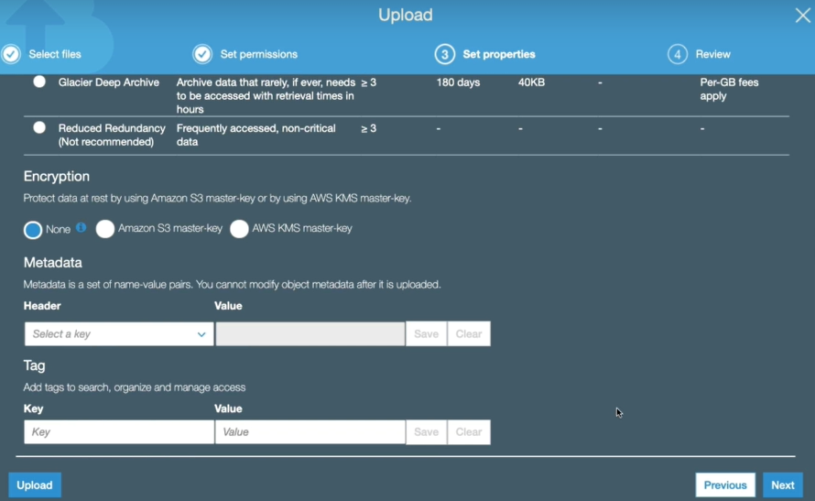

* We can also select the encryption and metadata as well. Then in next step, we can review all and upload the file.

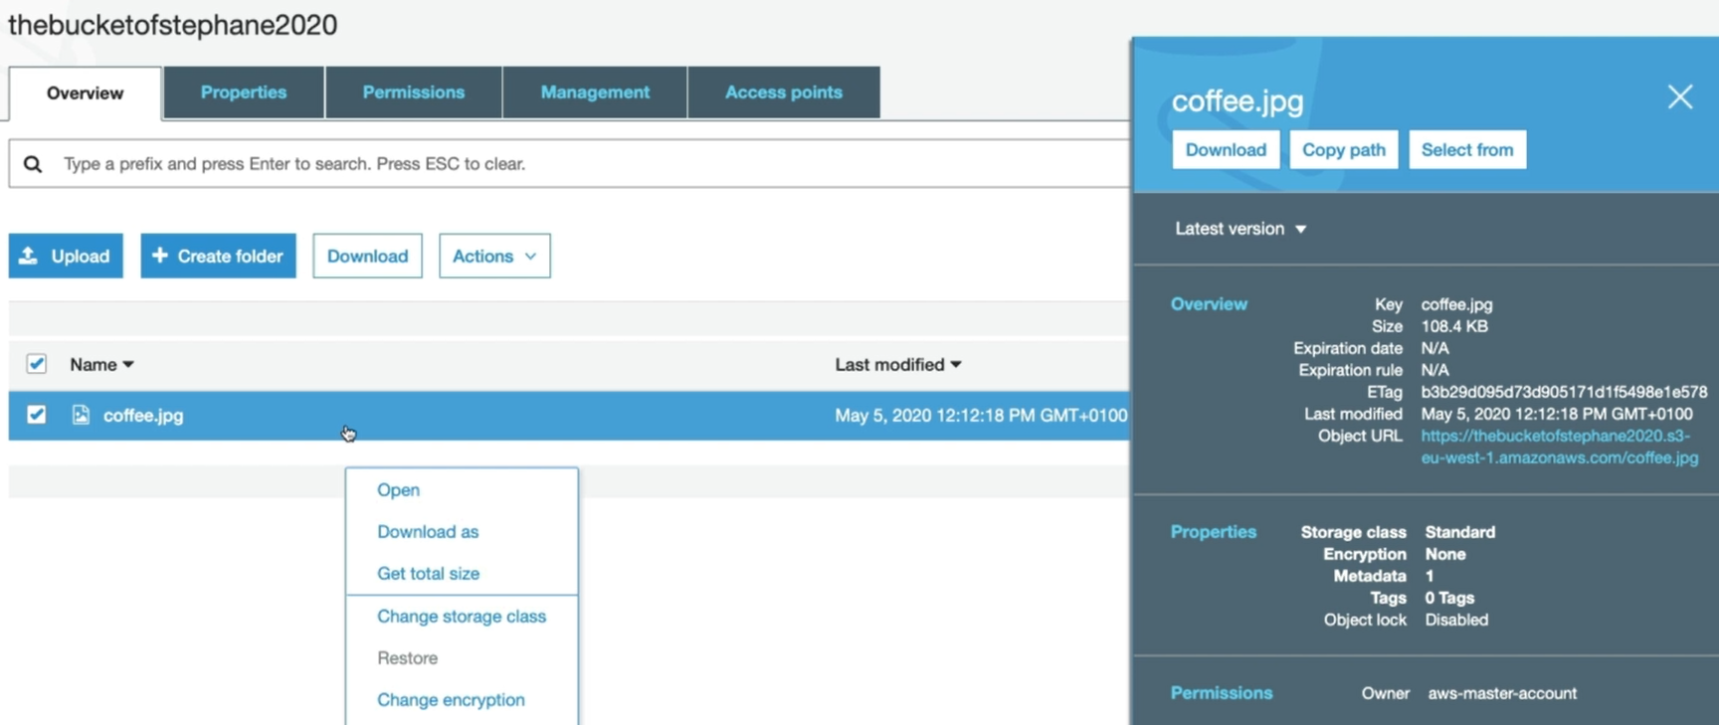

* Once we click on the file, we can see the info of a file on the right side of the screen as above.
* We can also right click on the file and click on open to view the data inside file.

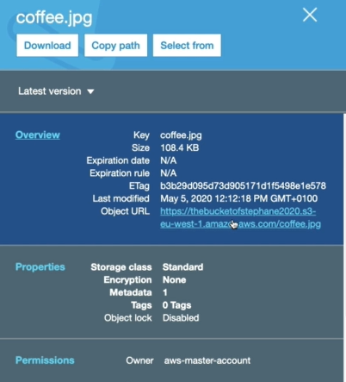

* We can also use the above URL of an object to access the file instead of right click and open it.

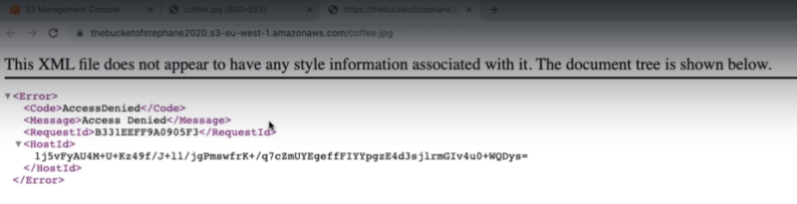

* We can also create folders inside the object and upload the files there as well.

**But the URL can only be used when the object has public access. Otherwise we will get access denied as above. We need to use right click and open option to view the private object.**